AI-Based Damage Detection System Models
By
GURUDEV. A

TABLE OF CONTENT

S.NO | TITLE | PAGE NO
1 | Project Overview | 1
2 | Literature Survey | 3
3 | Model Comparison | 7
4 | Datasets Selection Process | 10
5 | Training Process | 12
6 | Hyper Parameters | 14
7 | Pretrained Weight Calculation | 16
8 | Excepted Outcome | 19

PROJECT OVERVIEW:
AI-Based Damage Detection System Using YOLOv11
The Damage Detection System is a solution that uses Artificial Intelligence and Computer Vision to find and classify damages from pictures. This system uses a kind of AI model to look at images and detect damages like scratches, dents, cracks, broken parts and structural defects.
Traditional methods of checking for damages require people to manually look at everything, which takes a lot of time is work and can be inaccurate. Our system solves these problems by using the AI techniques to automatically assess damages with high accuracy and efficiency.
Here's how it works: the system takes an image finds the damaged areas draws a box around them and gives a score for how sure it's. This makes inspections faster more consistent and cheaper.
This solution is great for industries like car insurance, vehicle inspection, manufacturing, infrastructure monitoring, construction safety and asset maintenance.
By combining Computer Vision and AI models the Damage Detection System aims to provide fast, scalable and reliable damage detection for modern industries.

Key Features

• Automated damage detection, from images

• Real-time object detection

• Damage localization

• Confidence score prediction

• Multiple damage type classification

• Scalable deployment

• Less manual inspection

• Better inspection accuracy

Target Damage Categories

• Scratch

• Dent

• Crack

• Broken Part

• Surface Damage

• Structural Damage

LITERATURE SURVEY:

Faster R-CNN
Damage detection using Computer Vision and Deep Learning is super important. Without these tools, we rely on traditional manual inspections which take forever, cost a lot, and can be inaccurate because of human errors. Luckily, new AI tech now lets us build systems that find damage way faster and more accurately.

There have been tons of object detection models popping up lately. These aim to boost accuracy, speed things up, and make models easier to deploy. Below, I'll quickly look at some key architectures, but let's focus on one: Faster R-CNN from 2015.

Faster R-CNN came out with a neat two-step approach for finding objects. It uses something called a Region Proposal Network to guess where the objects are, then figures out what those objects actually are.

This system checks all the right boxes for academic work – the precision is great and it knows exactly where stuff is located. But, it's not perfect. Inference takes a long time, eats up tons of computing power, and isn't good for real-time needs.

Despite its speed issues, Faster R-CNN still shines in specific areas. People use it for spotting cracks in structures, spotting defects in factories, and figuring out vehicle damage.

Mask R-CNN

Mask R-CNN is an advanced computer vision model used for object detection and instance segmentation. It extends Faster R-CNN by adding a mask prediction branch that generates pixel-level segmentation masks for detected objects.
- Detects objects and predicts bounding boxes
- Generates segmentation masks for each object instance
- Uses a Fully Convolutional Network (FCN) for mask prediction
- Provides accurate pixel-level object segmentation
- Widely used in computer vision and image analysis applications

Instance Segmentation
Instance segmentation identifies and separates each individual object present in an image by assigning unique pixel-level masks to every object instance.
- Detects and segments each object separately
- Classifies individual pixels belonging to objects
- Generates segmentation masks for each object instance
- Provides detailed object boundaries and localization
- Helps improve object understanding in images

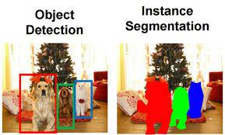

Applications

- Human pose estimation and body part detection
- Self-driving cars for object and lane detection
- Drone image mapping and aerial analysis
- Medical image segmentation and analysis

YOLOV5 Model(2020):
YOLOv5u represents an advancement in object detection methodologies. Originating from the foundational architecture of the YOLOv5 model developed by Ultralytics, YOLOv5u integrates the anchor-free, objectness-free split head, a feature previously introduced in the YOLOv8 models. This adaptation refines the model's architecture, leading to an improved accuracy-speed tradeoff in object detection tasks. Given the empirical results and its derived features, YOLOv5u provides an efficient alternative for those seeking robust solutions in both research and practical applications.

Supported Tasks and Modes
The YOLOv5u models, with various pretrained weights, excel in Object Detection tasks. They support a comprehensive range of modes, making them suitable for diverse applications, from development to deployment.
Pertained Weights:
yolov5nu, yolov5su, yolov5mu, yolov5lu, yolov5xu, yolov5n6u, yolov5s6u, yolov5m6u, yolov5l6u, yolov5x6u
Performance metrics:
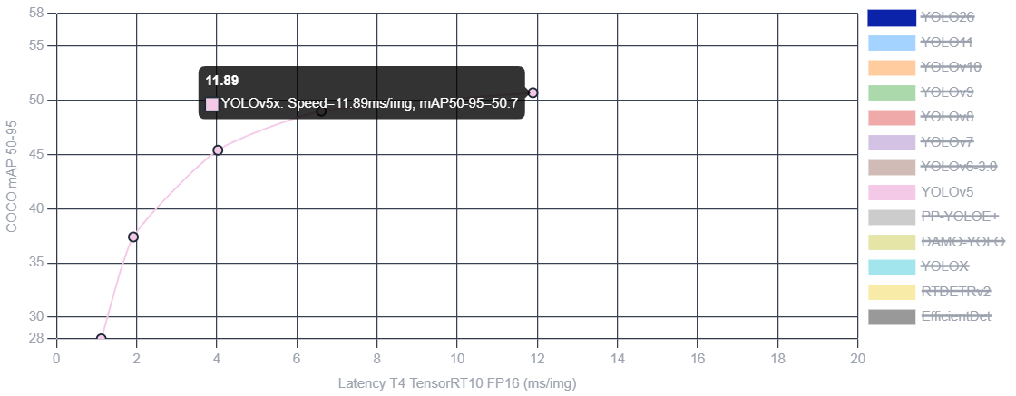
The performance comparison graph demonstrates the trade-off between inference latency and detection accuracy across YOLOv5 variants. As model size increases from YOLOv5n to YOLOv5x, detection accuracy improves significantly, while inference latency also increases. YOLOv5x achieves the highest mAP score of approximately 50.7 but requires around 11.89ms per image. This indicates that larger models provide superior detection performance at the cost of increased computational requirements.

YOLOV11 Model:
YOLO11 was released by Ultralytics on September 10, 2024, delivering excellent accuracy, speed, and efficiency. Building upon the impressive advancements of previous YOLO versions, YOLO11 introduces significant improvements in architecture and training methods, making it a versatile choice for a wide range of computer vision tasks. For the latest Ultralytics model with end-to-end NMS-free inference and optimized edge deployment, see YOLO26.

Performance Metrics:
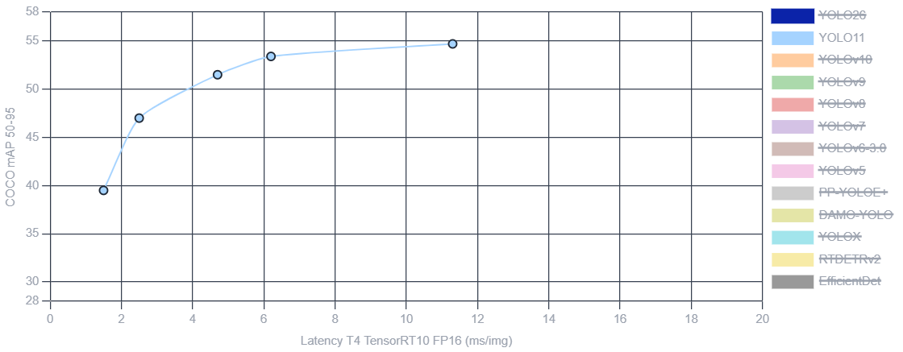
Model Comparison:
Comparative Analysis of Damage Detection Models
To identify the most suitable model for the proposed Damage Detection System, multiple object detection architectures were evaluated based on detection accuracy, inference speed, computational requirements, deployment complexity, and real-time performance.

Comparison Table
Parameter | Faster R-CNN | Mask R-CNN | YOLOv5 | YOLO11
Release Year | 2015 | 2017 | 2020 | 2024
Detection Accuracy | High | Very High | High | Very High
Inference Speed | Medium | Medium | High | Very High
Real-Time Capability | No | No | Yes | Yes
Deployment Complexity | Medium | High | Low | Low
Computational Cost | High | Very High | Medium | Medium
Small Object Detection | Good | Very Good | Good | Very Good
Scalability | Medium | Medium | High | Very High
Edge Device Support | Limited | Limited | Yes | Yes
Production Readiness | Medium | Medium | High | Very High

Model Evaluation
Faster R-CNN
Strengths:
- High object localization accuracy
- Reliable detection performance
- Strong research foundation
Limitations:
- Slow inference speed
- High computational requirements
- Not suitable for real-time systems

Mask R-CNN
Strengths:
- Pixel-level segmentation
- Detailed damage localization
- Excellent detection accuracy
Limitations:
- Complex deployment
- High resource consumption
- Reduced real-time capability

YOLOv5
Strengths:
- Fast inference
- Easy deployment
- Lightweight architecture
- Suitable for real-time applications
Limitations:
- Lower accuracy compared to newer architectures
- Limited performance on complex damage patterns

YOLO11
Strengths:
- High detection accuracy
- Improved feature extraction
- Faster inference speed
- Better scalability
- Production-ready architecture
- Real-time damage detection capability
Limitations:
- Requires high-quality annotated datasets
- Performance depends on proper hyperparameter tuning

Final Model Selection
Selected Model: YOLO11
Selection Justification
YOLO11 was selected as the preferred model for the proposed Damage Detection System due to the following reasons:
- High detection accuracy for scratches, dents, cracks, and structural damages.
- Real-time inference capability suitable for industrial applications.
- Better speed-to-accuracy balance compared to previous models.
- Easy deployment across desktop, cloud, and edge environments.
- Reduced computational complexity compared to segmentation-based models.
- Production-ready architecture with strong scalability.
Expected Benefits
- Faster inspection process
- Improved damage detection accuracy
- Reduced manual effort
- Real-time monitoring capability
- Scalable deployment for industrial use

Conclusion
Based on the comparative analysis, YOLO11 provides the best balance between accuracy, speed, deployment efficiency, and real-time performance. Therefore, YOLO11 is selected as the primary model for the proposed AI-Based Damage Detection System.

Dataset Selection
Dataset Overview
The performance of any damage detection model depends heavily on the quality and diversity of the training dataset. For this project, a vehicle damage detection dataset containing multiple categories of damages was selected to train and evaluate the model.
Dataset Characteristics
Dataset Type:
- Object Detection Dataset
Annotation Format:
- YOLO Format
Image Format:
- JPG / PNG
Damage Categories:
- Scratch
- Dent
- Crack
- Broken Part
- Surface Damage
- Structural Damage
Dataset Distribution
Dataset Split | Percentage
Training | 70%
Validation | 20%
Testing | 10%
Example Distribution:
Category | Images
Training | 7000
Validation | 2000
Testing | 1000
Total | 10000

Dataset Selection Criteria
The selected dataset satisfies the following requirements:
- High-quality annotations
- Multiple damage categories
- Diverse lighting conditions
- Various camera angles
- Different damage severities
- Real-world industrial scenarios
Expected Benefits
- Improved model generalization
- Better detection accuracy
- Reduced overfitting
- Improved real-world performance

Training Process
Training Workflow
The model training process consists of the following stages:
Step 1: Data Collection
- Gather damage images from multiple sources.
- Verify image quality.
Step 2: Data Annotation
- Label damages using bounding boxes.
- Validate annotations.
Step 3: Data Preprocessing
- Resize images.
- Normalize pixel values.
- Remove corrupted samples.
Step 4: Data Augmentation
Applied Augmentations:
- Horizontal Flip
- Vertical Flip
- Rotation
- Scaling
- Brightness Adjustment
- Contrast Adjustment
- Mosaic Augmentation
Purpose:
- Increase dataset diversity
- Improve robustness
- Reduce overfitting
Step 5: Model Initialization
Selected
Model:
YOLO11
Pretrained Weights:
- COCO Pretrained Weights
Step 6: Model Training
The model is trained using transfer learning techniques to accelerate convergence and improve detection performance.
Step 7: Validation
The validation dataset is used to monitor:
- Precision
- Recall
- F1 Score
- mAP
Step 8: Testing
The final model is evaluated on unseen test images to assess real-world performance.

Hyperparameters
Training Configuration
Parameter | Value
Model | YOLO11
Image Size | 640 × 640
Epochs | 100
Batch Size | 16
Learning Rate | 0.001
Optimizer | AdamW
Weight Decay | 0.0005
Momentum | 0.937
Confidence Threshold | 0.25
IoU Threshold | 0.70
Patience | 20
Workers | 8
Device | GPU

Training Objectives
The training process aims to achieve:
Metric | Target
Precision | > 90%
Recall | > 88%
F1 Score | > 89%
mAP@50 | > 92%
mAP@50-95 | > 85%
Expected Output
The trained model will:
- Detect damage locations
- Draw bounding boxes
- Classify damage types
- Generate confidence scores
- Support real-time inference
- Improve inspection efficiency

Pretrained Weight Calculation

1. COCO (Most Popular)
Dataset Size : ~118K images
Classes : 80
Use : General Object Detection

2. Open Images Dataset
Dataset Size : ~9 Million Images
Classes : 600+
Use : Large Scale Detection

Advantages:
- More object categories
- Better generalization

3. ImageNet Pretraining
Dataset Size : 14+ Million Images
Classes : 1000
Use : Feature Extraction
Most CNN backbones originally trained on ImageNet.

4. Objects365
Dataset Size : 600K+ Images
Classes : 365
Many modern detection models use this.

5. LVIS
Dataset Size : 2 Million+ Annotations
Classes : 1200+
Good for rare object detection.

Expected Outcome
Based on the comparative analysis of Faster R-CNN, Mask R-CNN, YOLOv5, and YOLO11, YOLO11 was selected as the optimal model for the proposed Damage Detection System due to its superior balance of accuracy, speed, and real-time performance.
The expected outcome is the development of an AI-powered damage detection system capable of accurately identifying and classifying damages such as scratches, dents, cracks, and broken parts from images while providing real-time detection, bounding box localization, and confidence score predictions with high efficiency and reliability.

